**1. Sum of Nums**

# Program Name: sumofnums.ypr

Given a number *n*, have Alonso calculate the sum of all the numbers between 0 and *n*

**Example Input File**

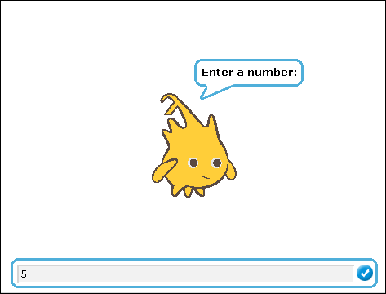

**Example Output to Screen**

